|  |
| --- |
| Name:  Ratnayake K Basura N B |
| Student Reference Number:  10541973 |



|  |  |  |
| --- | --- | --- |
| Module Code: **SOFT336SL** | Module Name: **Cross Platform Application Development in C++** | |
| Coursework Title: Assignment - User Manual | | |
| Deadline Date: **23/12/2015** | | Member of staff responsible for coursework:  Dr. Davide Marocco |
| |  |  | | --- | --- | | Programme:  **4872/3** |  | |  |  | | | |
| Please note that University Academic Regulations are available under Rules and Regulations on the University website [www.plymouth.ac.uk/studenthandbook](http://www.plymouth.ac.uk/studenthandbook). | | |
| Group work: please list all names of all participants formally associated with this work and state whether the work was undertaken alone or as part of a team. Please note you may be required to identify individual responsibility for component parts.  ***We confirm that we have read and understood the Plymouth University regulations relating to Assessment Offences and that we are aware of the possible penalties for any breach of these regulations. We confirm that this is the independent work of the group.***  Signed on behalf of the group: | | |
| Individual assignment: ***I confirm that I have read and understood the Plymouth University regulations relating to Assessment Offences and that I am aware of the possible penalties for any breach of these regulations. I confirm that this is my own independent work.***  Signed: | | |
| Use of translation software: failure to declare that translation software or a similar writing aid has been used will be treated as an assessment offence.  I *have used/not used translation software.  If used, please state name of software………………………………………………………………… | | |
| **Overall mark _____% Assessors Initials ______ Date_________** | | |



**Degree:** BSc (Honours) Software Engineering

**Stage:** 3

**Batch:** 14.2

**THE**

**FORE RUNNERS**

Believe everything is possible

**INDEX NUMBER FULL NAME**

10541973 Basura Ratnayake

Rahasa 1.0 – Customizable Encryption

User Manual

Table of Contents

Installation 1

Instructions 1

1. Home Screen 1

2. Encrypt Screen 2

3. Decrypt Screen 3

# Installation

**On Windows 10 and Kali Linux**

Launch the .pro file in the Rahasa application folder, configure and run the project using Qt Creator 4.0 or higher.

# Instructions

Rahasa is an application that encrypts and decrypts files, therefore in order to maintain the applications and encrypted files integrity certain radical security checks were introduced to the system.

## Home Screen

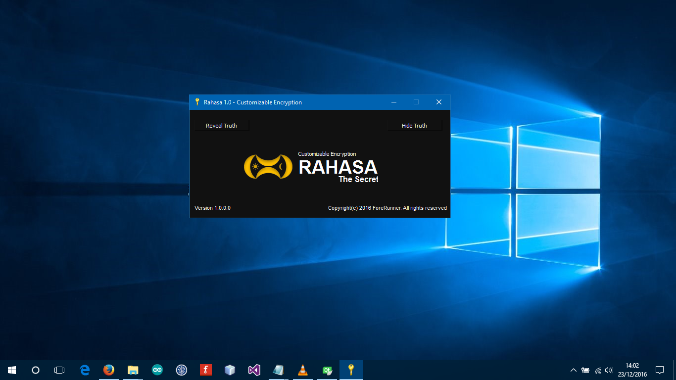From the home screen you can choose to **Encrypt** or **Decrypt** a file. All you need to do is click on the buttons on the top of the window.

* To Encrypt: Click **‘Hide Truth’**

Opens the encryption window to browse file to encrypt.

* To Decrypt: Click **‘Reveal Truth’**

Opens the decryption window to browse file to decrypt.

## Encrypt Screen

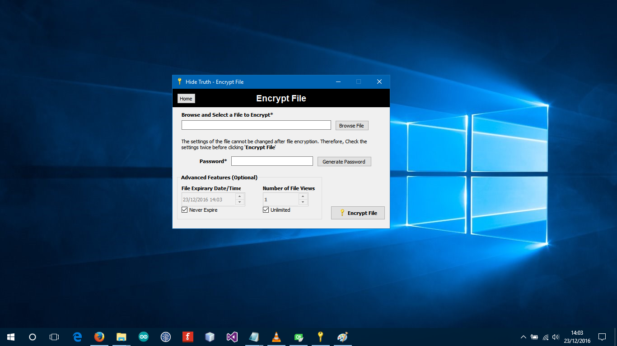

* **Browse File**

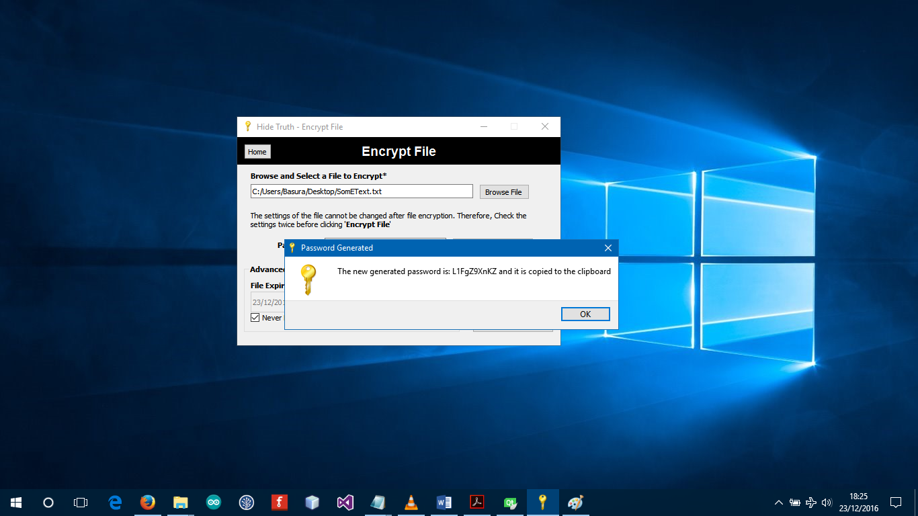Select only text files from the dialog. Note: It is possible to encrypt any file type but cannot display video, audio and other file types on our Viewer for now.

* **Generate Random Password**

You can enter a password yourself or generate a random password by clicking ‘**Generate’**. Once generated the password is copied to your clipboard.

## Decrypt Screen

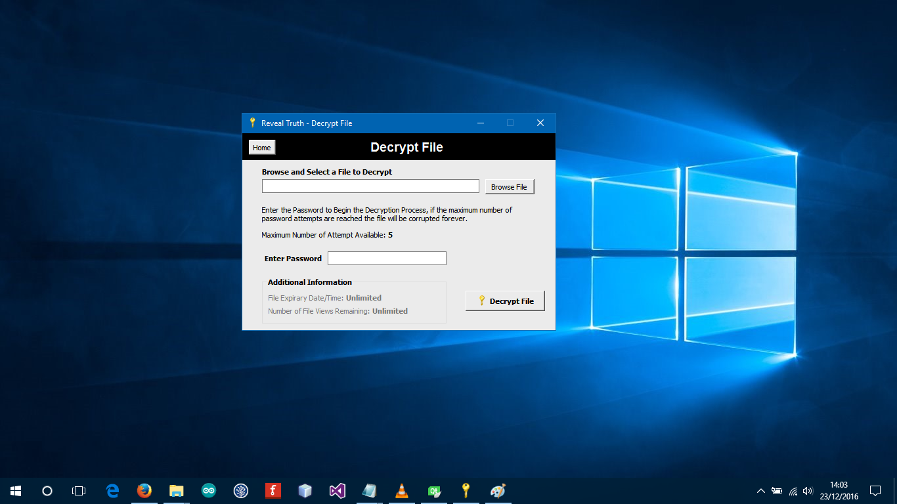

* **Browse the encrypted file**

Enter the password and click **‘Decrypt File’.**

**Note:** If file view limit or duration is exceeded the file be automatically corrupted.

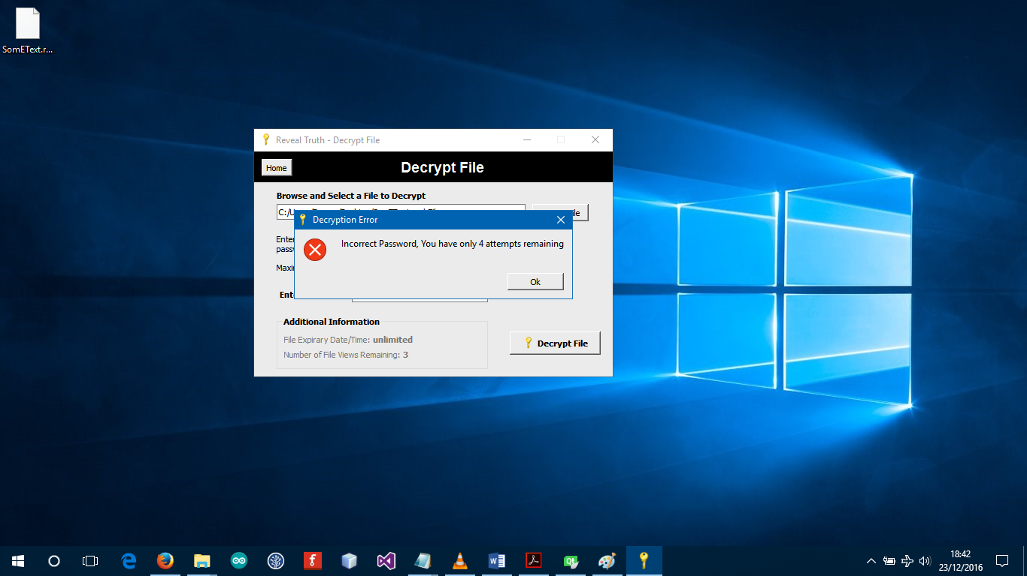

* **Incorrect Password**

If the maximum password attempt limit is exceeded, the file will be corrupted.